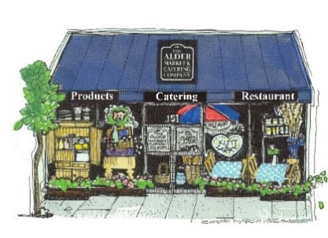
18 East Sonoma Avenue
Stockton, CA 95204
209-403-8834
info@aldermarketproducts.com

Dear Valued Customers and Vendors

All of us at Alder Products wish you a happy and successful Year. Last year was full of challenges as I am sure you are aware. We are happy that you and your business have stuck with us through it all. We have been working extremely hard on getting everything back on track here at Alder and are excited to grow.
We will need to adjust pricing going forward on most if not all items. The last general price adjustment took place at the end of 2017. Unfortunately, we are going to have to raise pricing due to several factors. We have done our best not to do price increases and absorb the inflation as much as possible, but we can no longer do so. We have had increases on most Ingredients and packaging along with others costs such as labor, general overhead, rent, shipping and insurance.
With the pandemic we had to make sure we implemented new safety protocols and coverages to make sure our team is safe and well taken care of, and have absorbed some downtime as a result, but we did not include these hopefully onetime costs in determining our pricing going forward.
The items listed below are the items and their new pricing. If there is an item that is not on this list, we will have to evaluate it before any new orders are placed. Once again, we really appreciate your business and your understanding with this and look forward to working with you and making 2021 a better year!
Shipping has been increasing on a regular basis and most areas are costing far more than the $23.50 full case or $20.50 half case currently being charged. We are working with FedEx to find the best rates available for a smaller company but will be increasing to $25.00 for a full case and $23.50 for a half case.
Distributor Prices in effect for all future orders per case of 12 will be $35.85; Wholesale Prices per case of 12 for future orders will be $39.80 and Retail Prices are increased to $46.85 per case of 12.
Thanks for your continued support.
Larry & Kitty Ruhstaller

